CSV File Name-‘Book.csv’
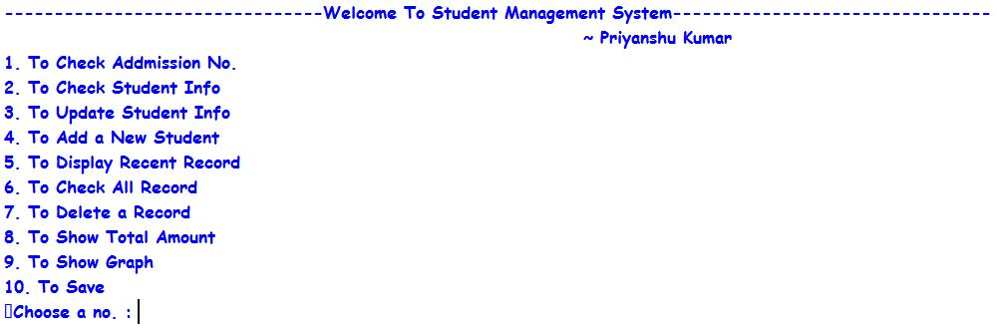
Main Menu Screen

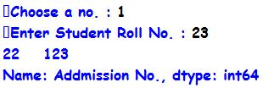
Choice 1 Output

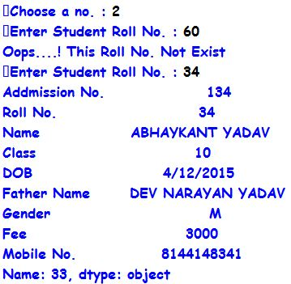
Choice 2 Output

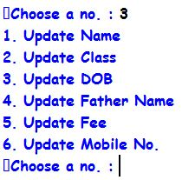
Choice 3 Output

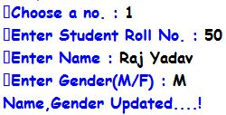
Internal Choice 1 Output

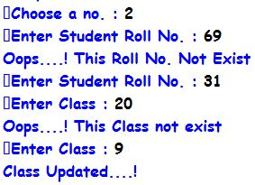
Internal Choice 2 Output

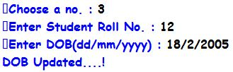
Internal Choice 3 Output

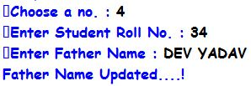
Internal Choice 4 Output

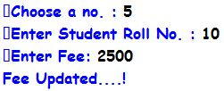
Internal Choice 5 Output

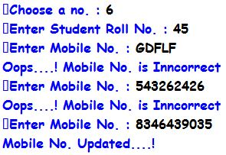
Internal Choice 6 Output

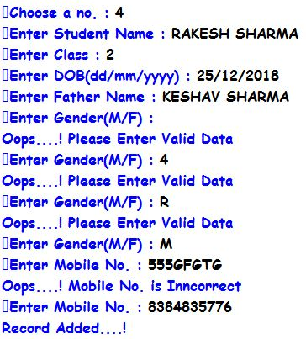
Choice 4 Output

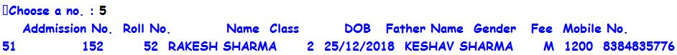
Choice 5 Output

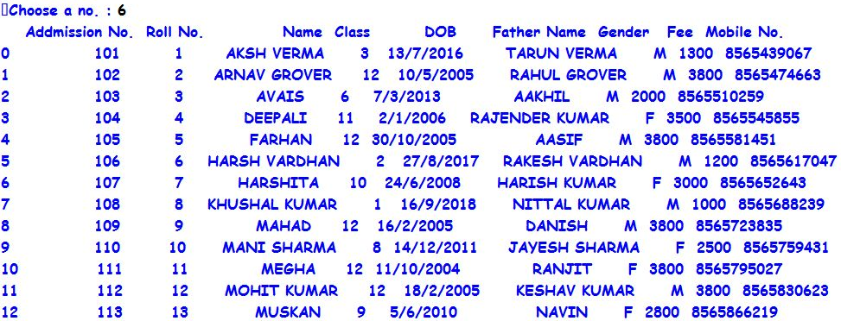
Choice 6 Output

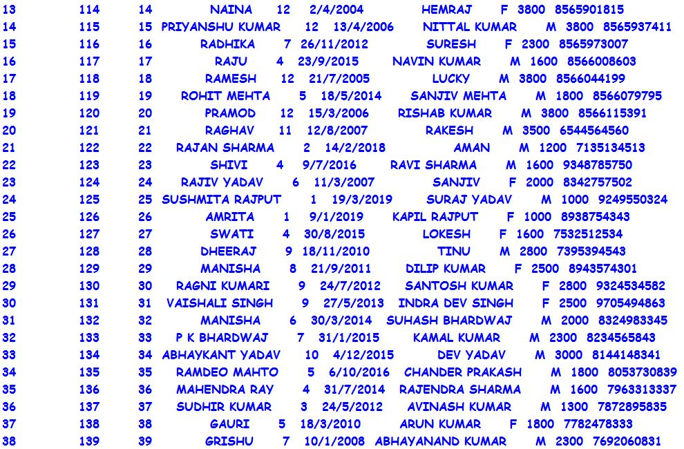

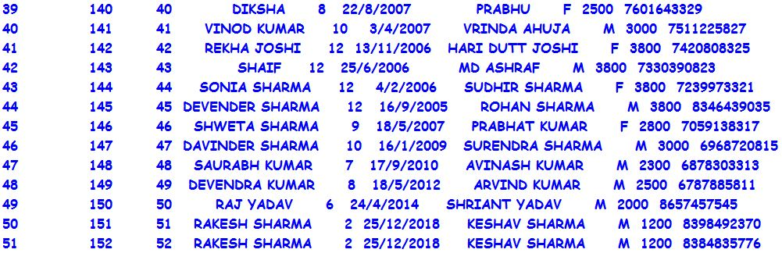

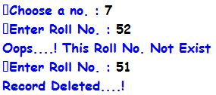
Choice 7 Output

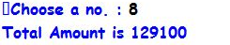
Choice 8 Output

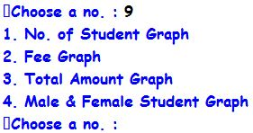
Choice 9 Output

Internal Choice 1 Output
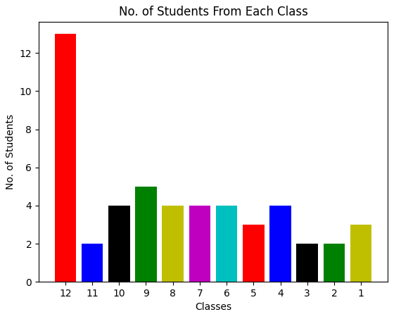

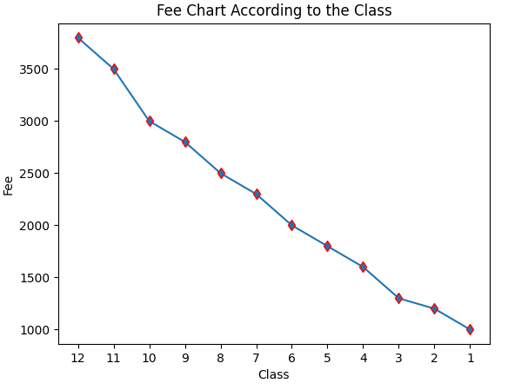
Internal Choice 3 Output

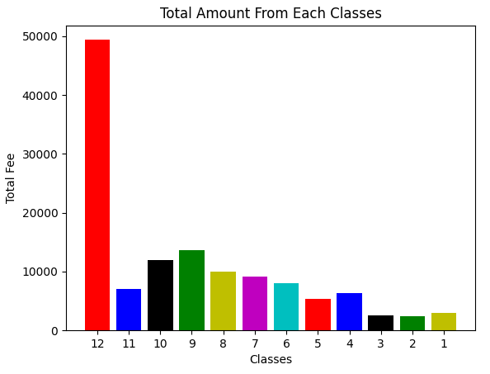
Internal Choice 3 Output

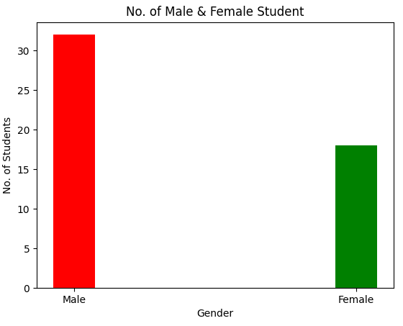
Internal Choice 4 Output

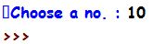
Choice 10 Output

HARDWARE & SOFTWARE REQUREMENT
Hardware Requirement
- Intel core/i3/i5/i7 or any equivalent with at least 256 MB RAM
- 2 MB free space on Hard Disk Colour Monitor/LCD
Operating System & Compiler
- Any Operating System
- Any Python Interpreter
- Pandas Library
- Matplotlib Library

THANK YOU

